

| **Title: Design Document for MiniProject.** |
| --- |

**______________________________________________________________________Objective:** **Understand the necessity of design document.**

**______________________________________________________________________**

**Expected Outcome of Experiment:**

Understand the necessity of design document.

**_________________________________________________________________**

**Books/ Journals/ Websites referred:**

<https://www.researchgate.net/figure/Blockchain-based-e-voting-system-architecture_fig2_357827345>

<https://www.investopedia.com/terms/b/blockchain.asp>

<https://core.ac.uk/download/pdf/155779036.pdf>

**______________________________________________________________**

**Introduction:**

As the process of development of a project progresses, the second important stage is the design.

**DIGIPOLLS**

**An e voting system using blockchain technology.**

**Interface**

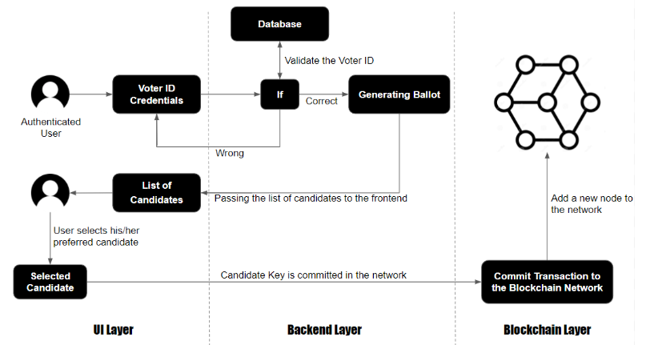

**Backend/ database design /Data design**

**SCHEMA**

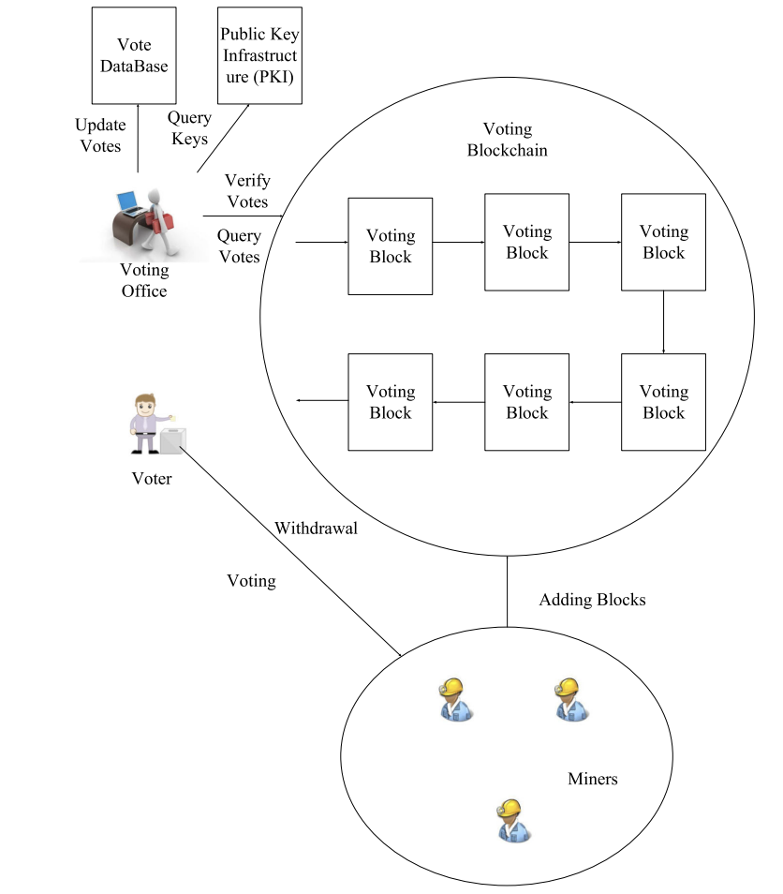

**VOTING BLOCK SCHEMA**

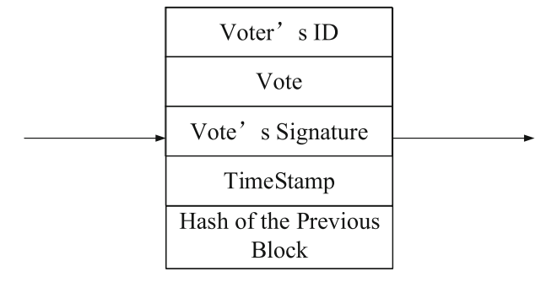

**INITIALIZATION OF VOTING SYSTEM**

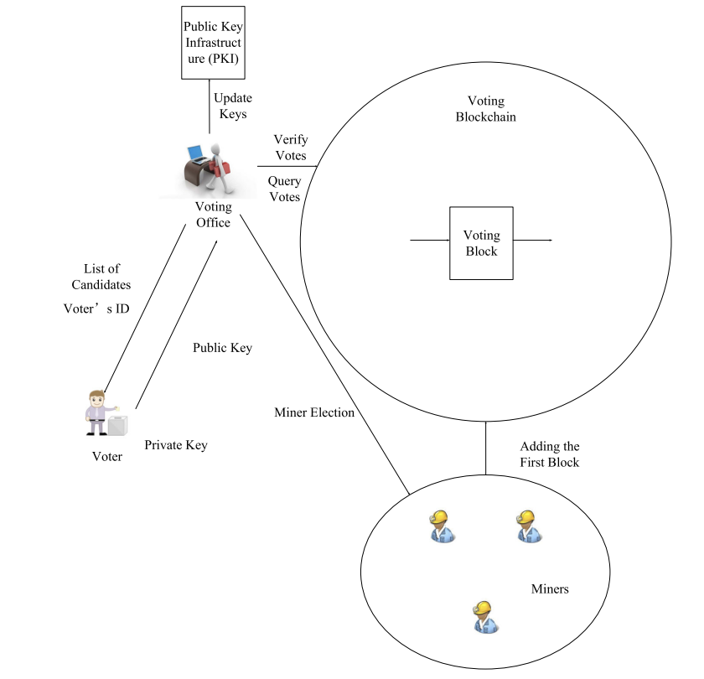

**VOTING**

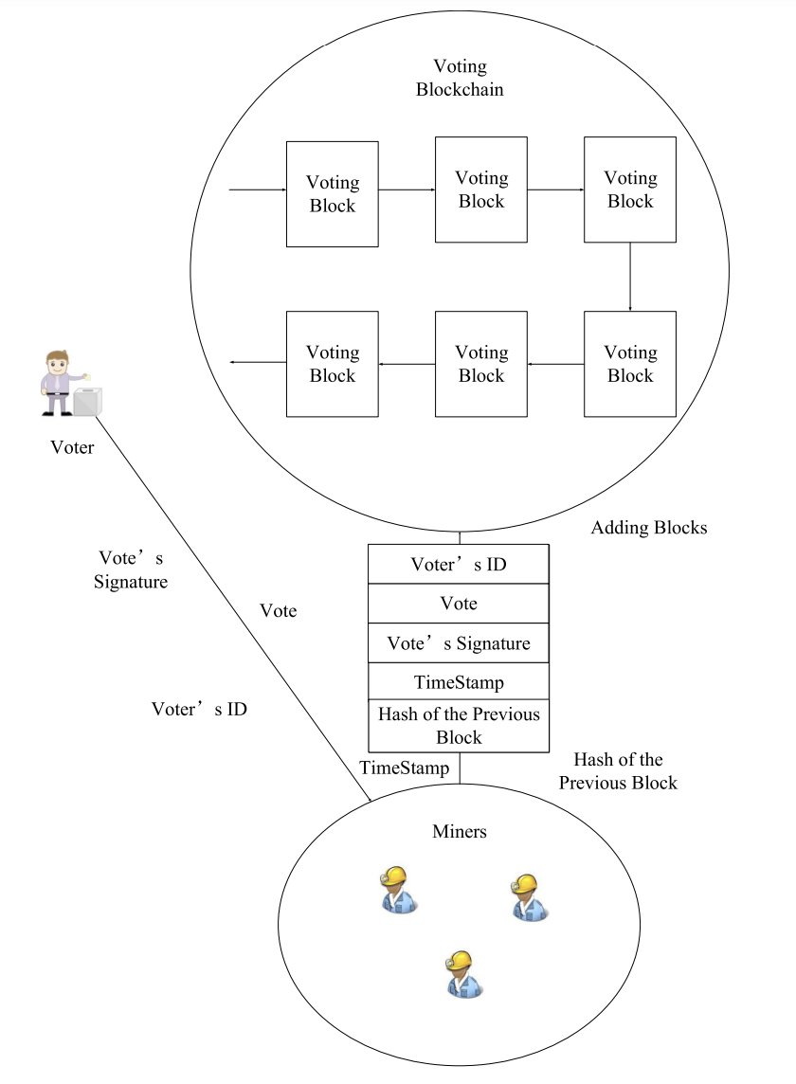

**Architectural design**

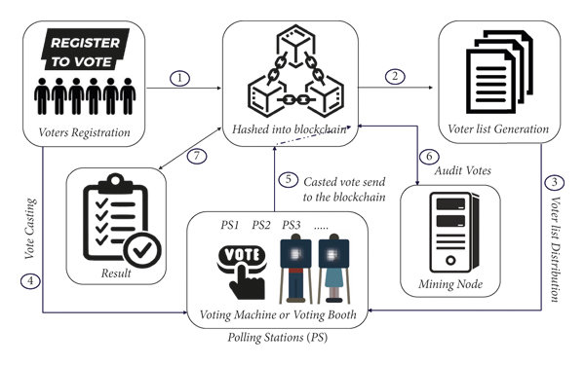

Above is reference from https://www.researchgate.net/figure/Blockchain-based-e-voting-system-architecture_fig2_357827345

SYSTEM ARCHITECTURE FOR VOTING

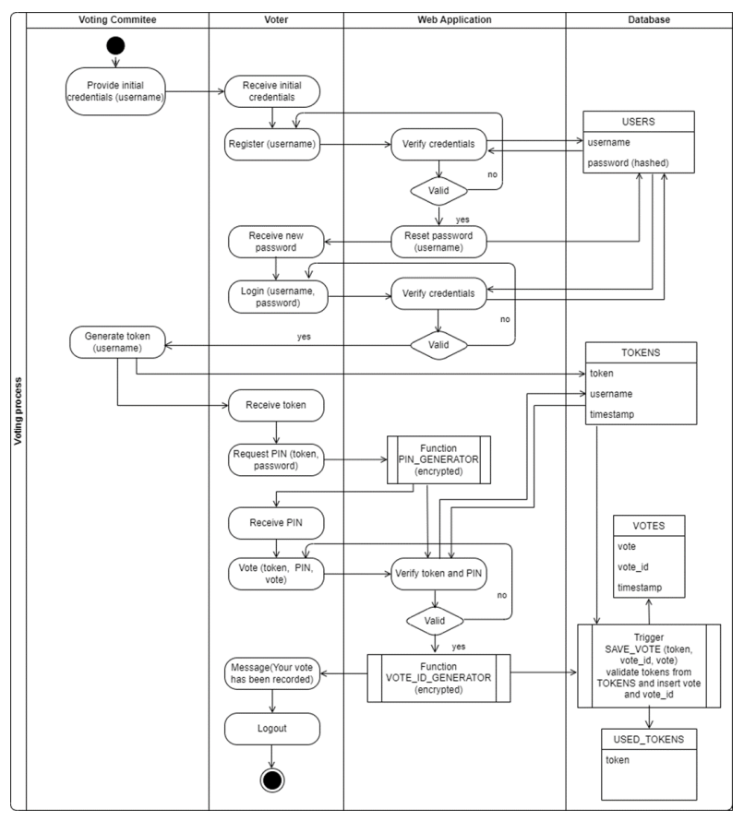

SYSTEM ARCHITECTURE FOR VALIDATION

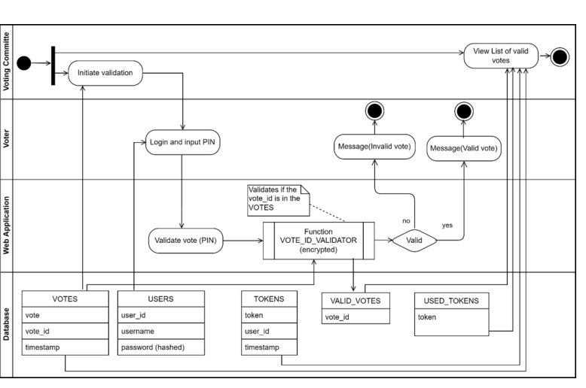

WORK FLOW

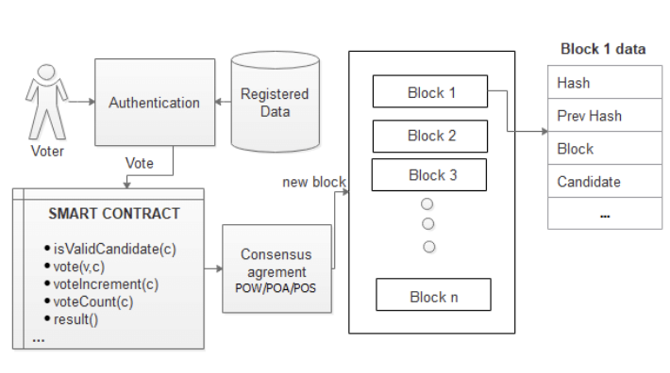

**UML diagrams**

1. Use-case diagram:

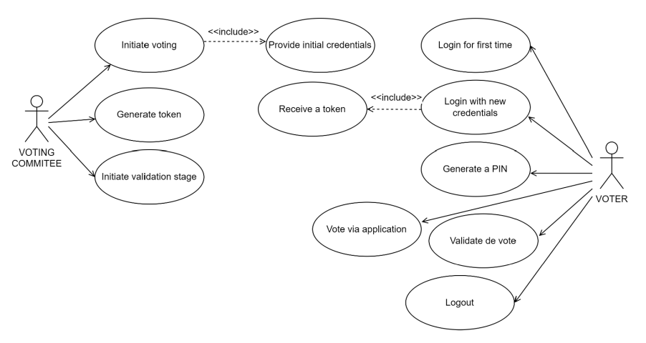

1. Sequence Diagram: Authentication

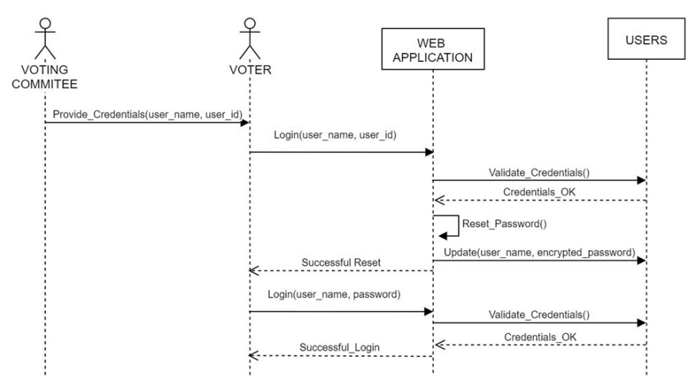

1. Sequence Diagram: voting

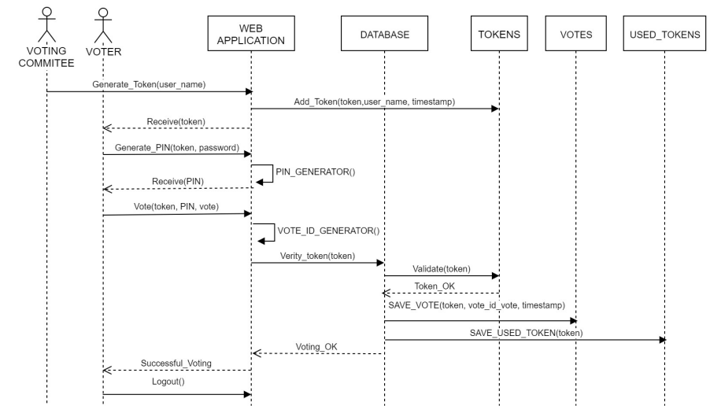

1. Sequence Diagram: Validation

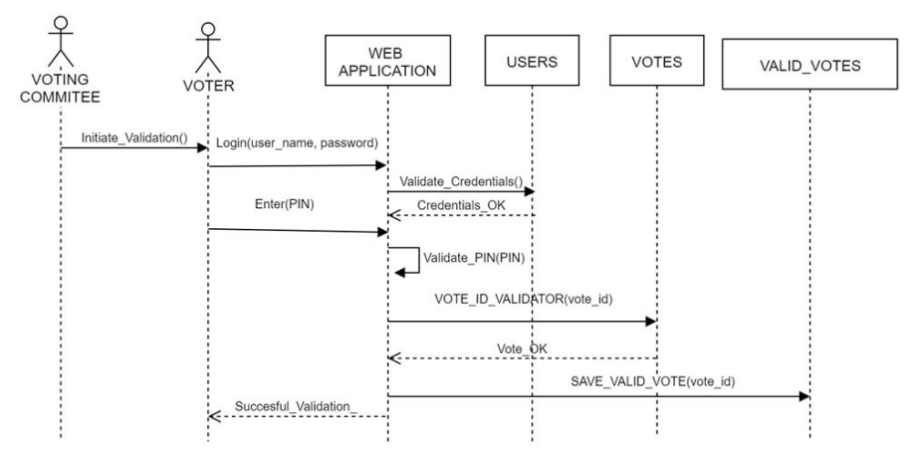

**Design of test cases.**

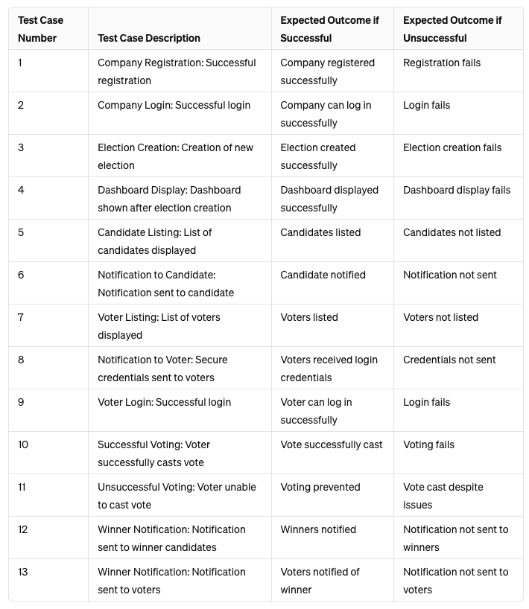

**Algorithmic design**

FOR VOTING

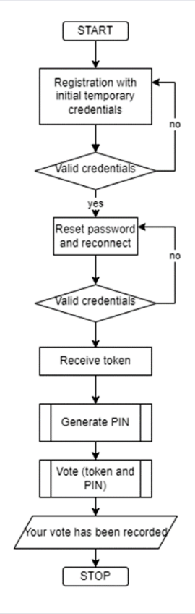

FOR VALIDATION

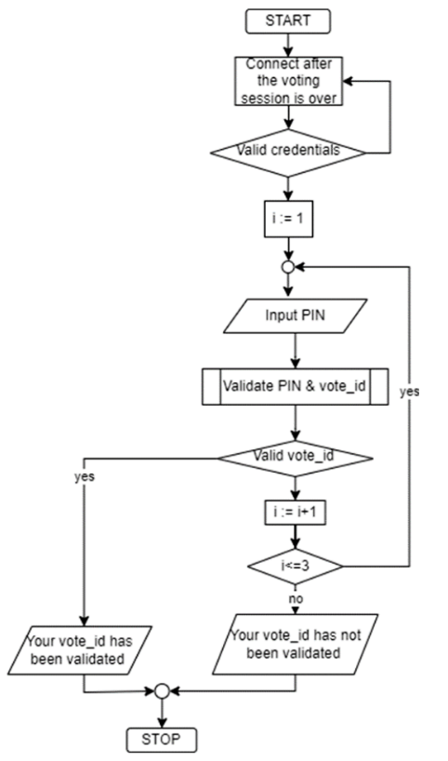

**Snapshots of design:**

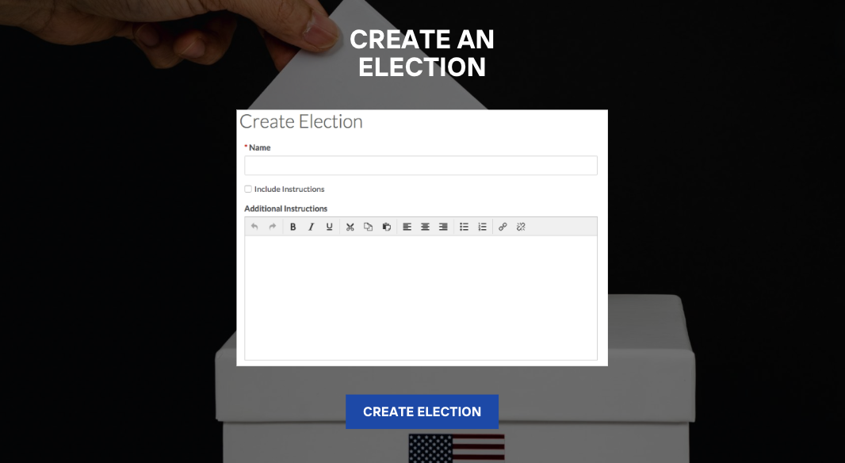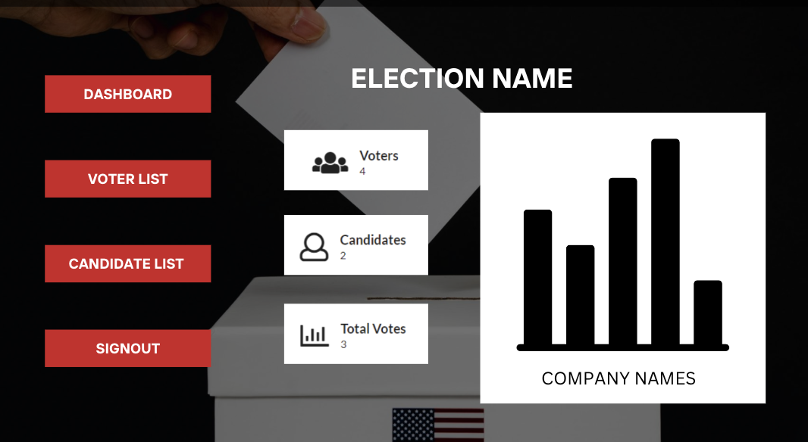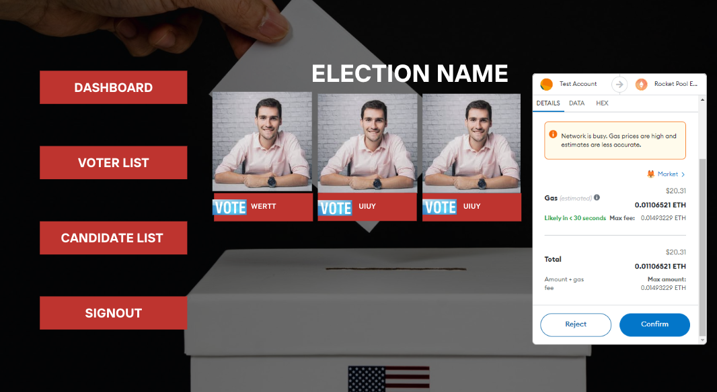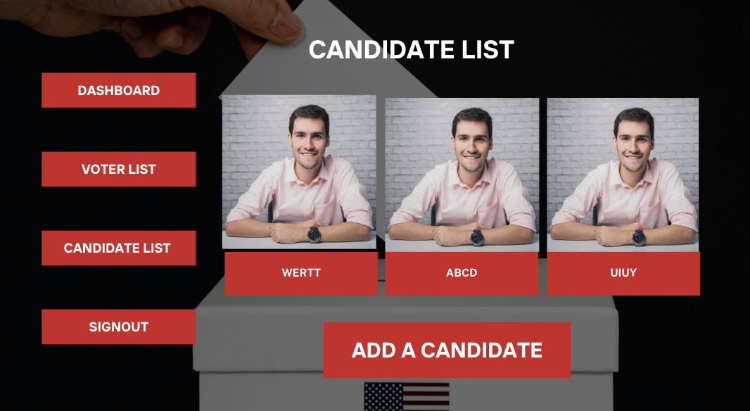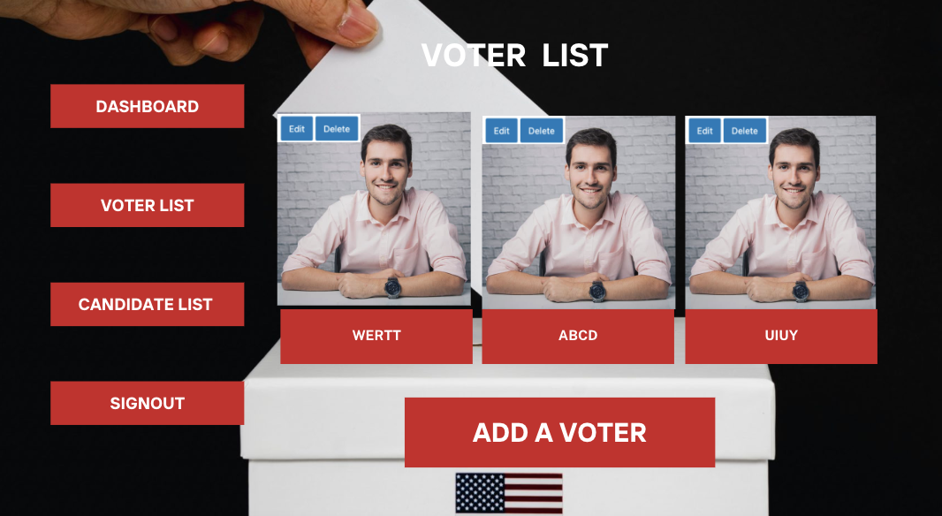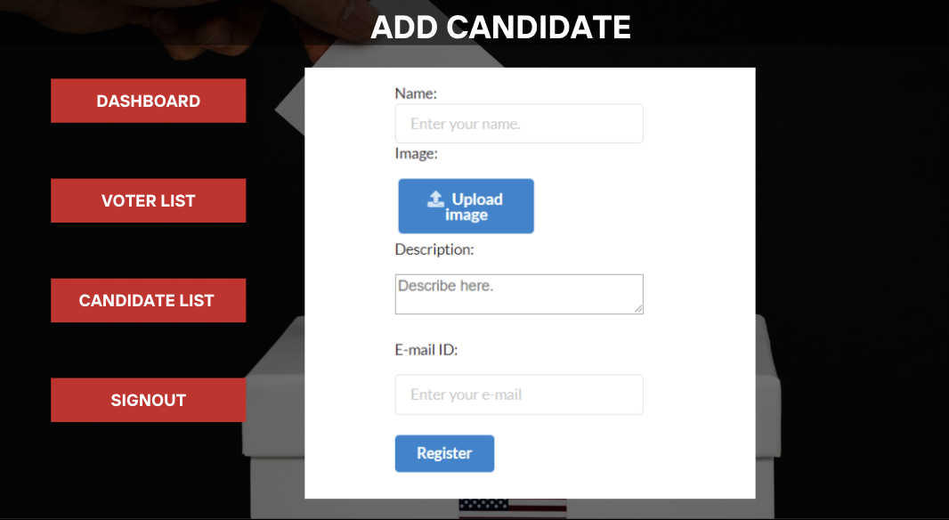



**Conclusion:**

The design presented here is well-suited for our e-voting system using blockchain in company elections. It ensures a smooth user experience, secure data handling, fault tolerance, and reliability. The inclusion of frontend interface, backend/database design, architectural design, UML diagrams, test case design, and algorithmic considerations guarantees the system's effectiveness, security, and usability. With thorough testing and emphasis on efficiency and security in algorithmic design, we're confident in the system's ability to facilitate transparent and trustworthy company elections.